Purpose: Bacteriophages are common in the environment, yet relatively few have been isolated and characterized. By sampling the environment for bacteriophage, students will learn some basic microbiological techniques and relate to microbiology in the context of their everyday lives.

Learning objectives: By the end of this laboratory-based module, students will be able to:
1. Describe what bacteriophages are and where they might be found.
2. Outline the key steps of isolating new viruses.
3. Interpret results and draw conclusions about where some types of bacteria and their bacteriophage are more common.
4. Describe basic interactions between phage and their hosts.
5. Appreciate their local microbial diversity.

Background: Although you cannot see them, microbes can be found just about anywhere. Bacteriophages (or phages) are viruses that infect bacteria. Bacteria and their associated bacteriophages represent only a subset of all microbes, but even these are incredibly diverse. There are currently five known families, or morphologies, of bacteriophage. Examples of each type of morphology is shown below. There are three types of tailed phages: the myoviruses have long, contractile tails; the siphoviruses have long, non-contractile tails; and the podoviruses have short tails. In addition to tailed phages, there are also non-tailed and filamentous phages. However, the tailed phages greatly outnumber their non-tailed and filamentous relatives.

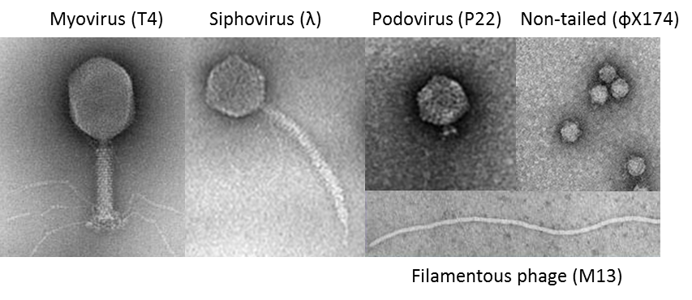

Since phage specifically infect bacteria, they can often be found anywhere bacteria may be found. In this laboratory exercise, you will be isolating your own bacteriophages and seeing which species of bacteria they infect. Some bacteriophages can infect many types of bacteria, while others can only infect a few. This is known as the bacteriophage’s host range, which is determined during various stages of the bacteriophage infection cycle. We will focus on only the first of these.

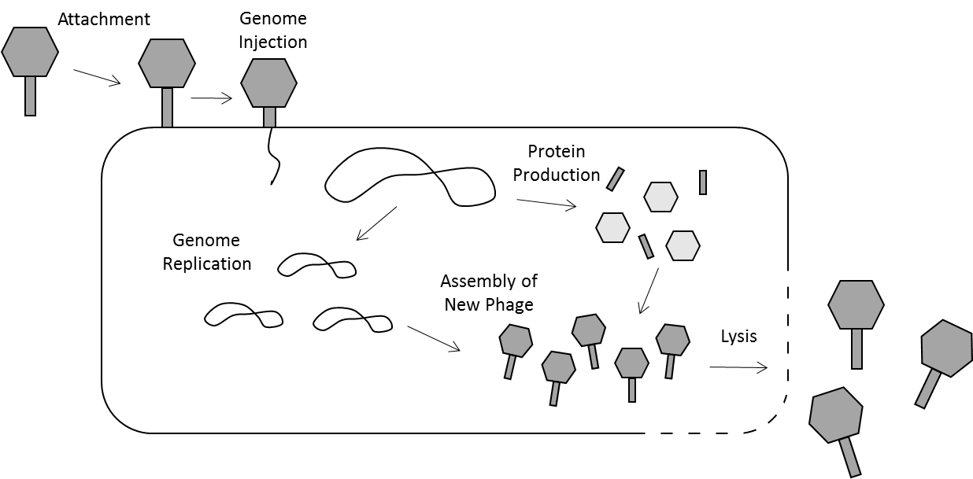

To begin an infection, the bacteriophage must first recognize its host. Upon finding a bacterial cell, it identifies one or two specific components, known as receptors, on the outside of the bacterium. If these receptors “match” the phage, then the phage can inject its genetic material, or genome, into the cell. If there is no match, the phage often detaches and find a different cell. This initial matching process is the first and most common factor affecting host range.

Once the bacteriophage’s genome is injected into the host cell, the host will begin making copies of the phage. After many copies have been produced, usually hundreds or thousands, the phage will often lyse the host cell to release the new phage copies. These phages can then find new host cells and begin the process again. With each successive round of infection, the phage population grows and kills many additional host bacteria. In the laboratory, this can be used to “see” where phages are. When bacteria and phage are grown on an agar plate, small clearings in the bacterial lawn (known as plaques) indicate regions where bacteria have been killed by phage!
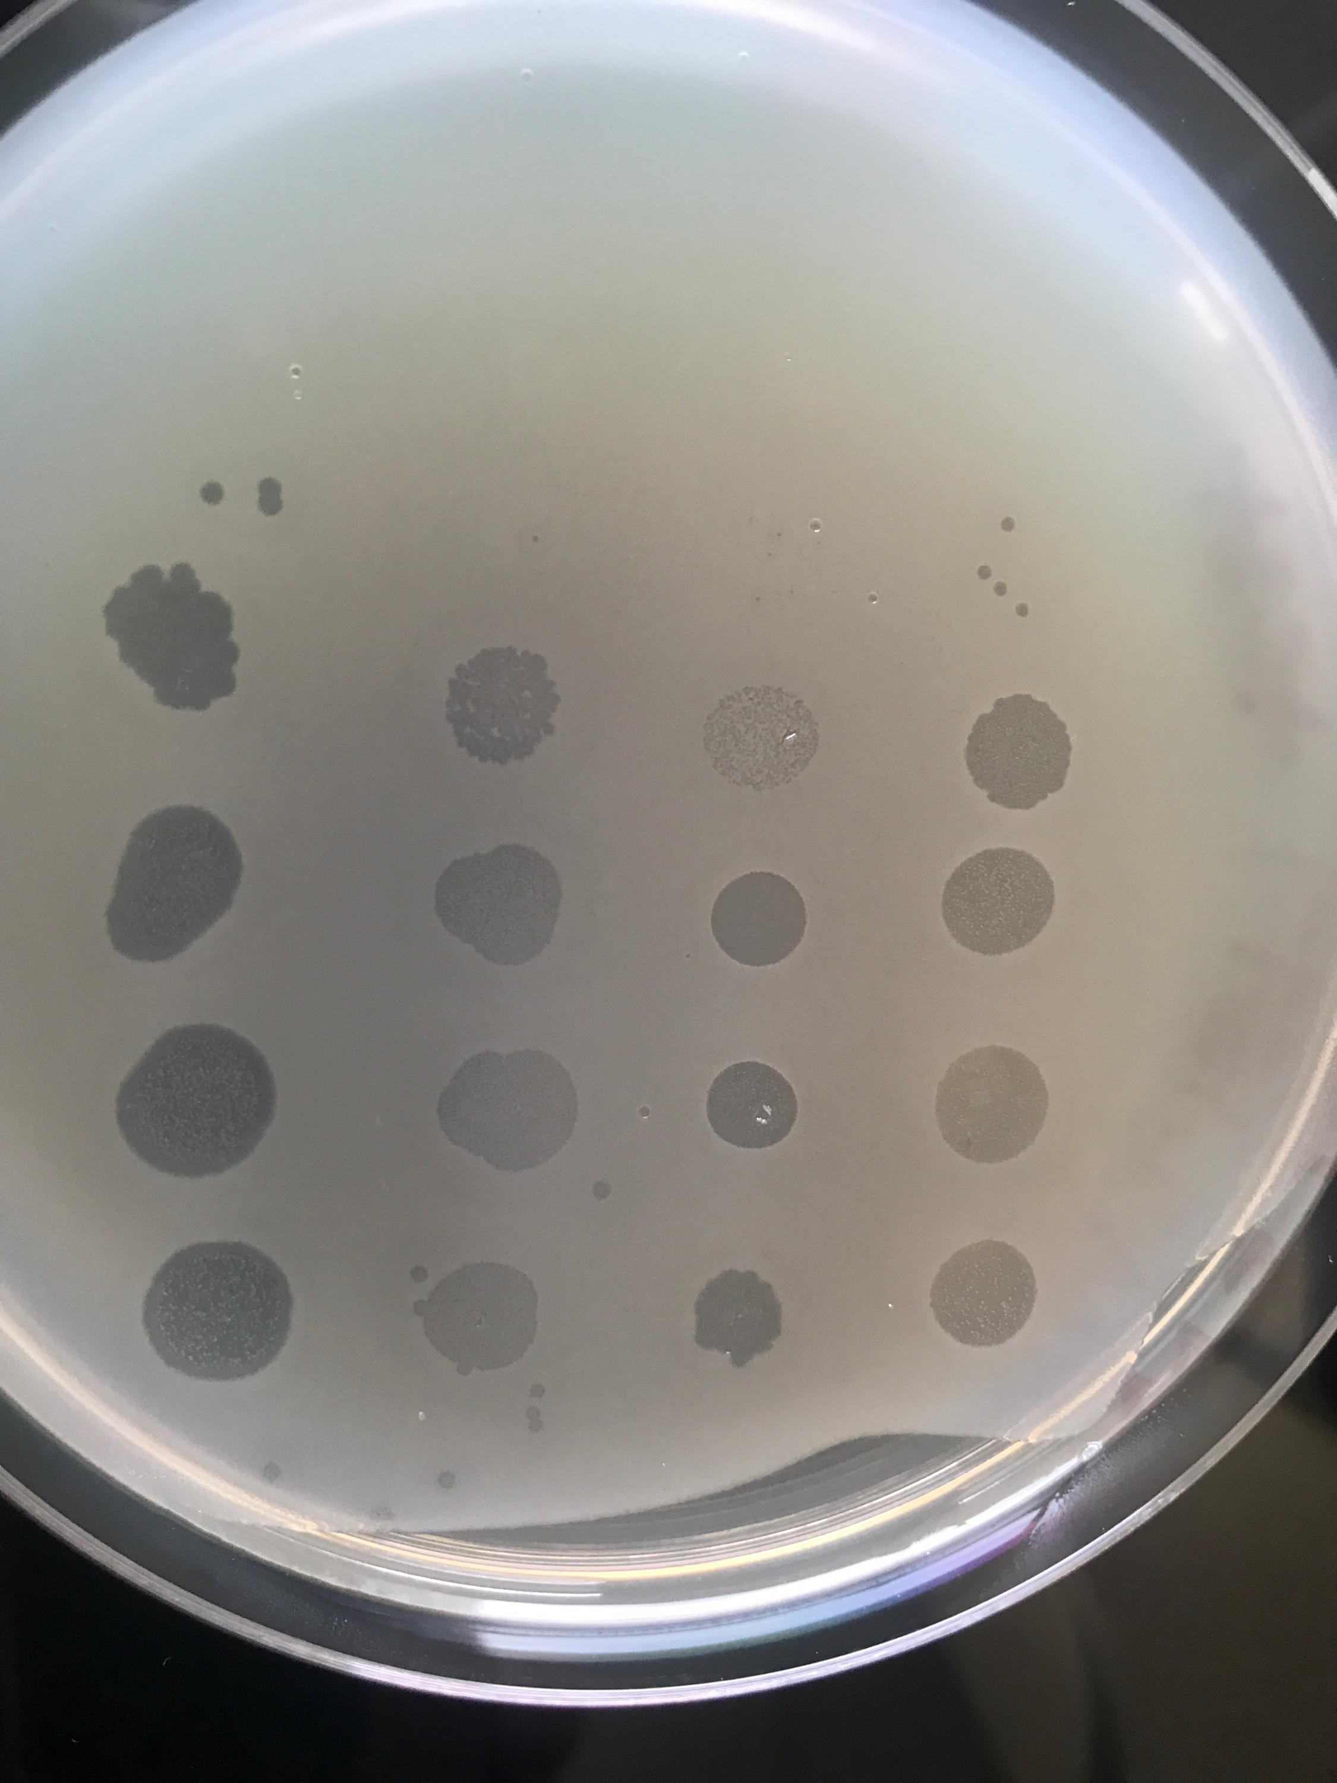

Left plate is from a spot test and the right plate is the result of a “stab & swirl” from an isolated colony
Materials:
Plates with bacterial colonies
Serological pipettes (5ml) and bulbs
Glass pasteur pipettes and bulbs
Conical tubes (15ml and 50ml)
Luria Broth (LB)
Glass tubes and caps (13mm)
Toothpicks or small wooden dowels
Syringes (30ml) and syringe filters (0.45µm)
Soft agar (0.3%)
Pre-poured agar plates
Phage dilution buffer (10mM Tris, 10mM MgCl₂)

Day One: Sample Collection
Take a 50ml conical tube to your sampling location. For soil or other solids, aim to fill the tube about halfway full (to the 25ml mark). For liquid samples, fill the entire tube. Keep the sample chilled overnight if possible, but avoid putting unknown microbes in a fridge full of food! Place your sample in a sealable bag or box before using the fridge, or use a small cooler box with a few cold packs if necessary.

Day Two: Sample Preparation
Pre-processing for soil or other solid samples:
Phage and bacteria can stick to the particles within soil, making it difficult to work with a soil sample directly. To solve this problem, phage can be detached from the particles by thoroughly mixing the sample with Luria Broth. This lets the phage be transferred from the solid soil particles into the liquid broth medium.
1. Add LB to cover the sample (to about the 40ml mark).
2. Shake vigorously for 2-5 min, or gently and repeatedly invert for 5-8 min (take turns within your group to save your wrists).
3. Set the tube on the benchtop, or in the refrigerator and let the solids settle. This process can continue overnight, and the next steps in the Removing environmental bacteria section can be done the following day before plating.

Pre-processing for water or other liquid samples:
Since these types of samples are already well-mixed and free of solids, no pre-processing is necessary. However, if your sample comes from pond scum or a lake filled with water plants, some removal of solid material may be necessary. If algae or duckweed is floating at the top, scrape it out with a clean spatula. If a chunk of plant or other solid material got into your tube, remove it with a pair of clean tweezers.

Removing environmental bacteria:
There are a lot of bacteria in the environment, and now they are in the conical tube along with your phage. If you tried to work with your sample at this point, the environmental bacteria would complicate the experiment. To solve this problem, the sample can be filtered through a 0.45µm filter. The pores in this filter are big enough to let the bacteriophage through and small enough to keep bacteria out.
1. To prepare the syringe, remove the plunger and twist the filter onto the syringe tip.
2. Open a new, sterile 50ml conical tube and set it upright on the benchtop. Someone can hold this while another group member filters the sample.
3. Rest the filter/syringe on top of the opening.
3. While keeping one hand on the syringe, carefully pour the cleared liquid sample into the barrel. Be careful not to transfer too much solid material if present in your sample. If solids do get into the syringe, they will clog the filter.
4. Re-insert the plunger. Push the plunger down until all the liquid has gone through the filter. If it becomes too difficult, or if too many solids got into the syringe barrel, you may have to replace the filter once or twice. To do this, be sure to release the pressure on the plunger before exchanging filters. Forgetting to do this may cause you to lose quite a bit of your sample!
5. Close the conical tube. Make sure it is labeled, then store it in the refrigerator.

Growing bacterial cultures for a host range screen:
Now that the environmental bacteria have been removed, the phage have no hosts to infect. Since we are looking for phage that infect specific bacteria, your sample will be screened on only those types.
1. Add 5ml LB to a labeled, sterile 15ml conical tube.
2. Remove parafilm from a plate that has been streaked for single colonies of bacteria.
3. Using a toothpick or wooden dowel, gently touch an isolated colony, then transfer it to the conical tube. Do this by swirling the tip that contains bacteria directly in the LB.
4. Close the tube but keep the cap loose because the bacteria need oxygen to grow. Shake or mix overnight.
Repeat this process for all types of bacteria you will be using to screen for phage.

Day Three: Screening for Phage
Plating bacteria using soft agar overlay:
Since many phage kill (or lyse) their hosts, phage are “seen” by looking for areas where bacteria cannot grow, or where bacteria have been killed. These dead zones are known as plaques, which look like small, clear circles on an agar plate. To see these plaques clearly, the entire plate must be seeded with bacteria. An easy way to do this is by mixing bacteria with soft agar, then spreading the soft agar across the top of a plate. The soft agar solidifies quickly and evenly.
1. Soft agar is liquid at 55°C and will remain soft as low as about 45°C. To keep the soft agar in this state, it is distributed into 13mm tubes that are held at 45°C in the water bath while the rest of the materials are assembled. If it becomes solidified, you can use a microwave to re-melt the soft agar.
2. Take a pre-poured agar plate and label the bottom with the date, cell type, the name of the environmental sample, and your group name.
3. To the soft agar tube, add 3 drops of an overnight bacterial culture.
4. Briefly vortex or flick the tube to mix. This will ensure the bacteria are evenly distributed within the soft agar.
5. Pour the entire contents of the tube over the plate and swirl or shake until it is evenly spread across the surface. The soft agar begins to solidify after about 10 seconds, so do this carefully but quickly! Otherwise the plate will appear chunky and it will be difficult to accurately pick out plaques from distortions in the lawn.
6. Let the plate dry for about 5 minutes.
7. Repeat this process for all strains of bacteria.

Testing samples for phage (plating method):
You can now begin testing your environmental sample for phage. To test this using the plating method, a small volume of the sample is spotted directly onto the plates that were just overlaid with bacteria. The liquid will need to dry before putting them in the incubator, so only use 250 µL (0.25 mL).
1. Pipette 250 µL of your environmental sample into the middle of the plate, letting it form a puddle. Be careful not to touch the agar.
2. Repeat this process for each plate of bacteria.
3. Let the plates dry. This could take a couple hours.
4. Once dry, turn the plates over and place them in the 37 ˚C incubator and leave them overnight.

Testing samples for phage (liquid culture method):
Some phage may have a difficult time diffusing through the matrix of the soft agar. To make sure no phage are missed because of this, you can also use a liquid culture method.
1. Prepare a 15ml conical tube for each type of bacteria you will be testing. Label it with the date, the name of the bacteria, and the name of the environmental sample or of your group.
2. Add 5ml of LB, along with 50µl of the appropriate overnight culture.
3. Finally, add 250µl of your environmental sample.
4. Loosely close the tube and let it shake overnight.

Day Four: Collecting Data
You should now be able to see whether or not you’ve found any phage! Inspect each of your plates to see if there are any clearings in the lawn. It can be difficult to differentiate plaques from bubbles in the soft agar. You may want to test questionable plaques/bubbles just in case. Record how many plaques (or “plaques?”) you see for each plate. Also take a look at your liquid cultures. If any of them are clear, it likely indicates the presence of phage. Record which cultures are clear and which ones are turbid (i.e. full of happy bacteria).

Plaque purification:
If you think you’ve found a phage, it’s important to re-isolate or plaque purify it for several reasons: 1) it lets you confirm whether it is actually a phage or just a bubble, 2) gives you an isogenic (genetically identical) population for storage or future experiments, and 3) makes it easier to visualize and compare plaque morphologies.
1. Prepare an agar plate by labeling it with the date and names of the bacteria and environmental sample where the plaque is from.
2. Using a sterile toothpick, either stab the center of a plaque or swirl gently in a cleared liquid culture.
3. Stab the center of the agar plate with the toothpick (which now has phages stuck to it).
4. Add 3 drops of an overnight culture to soft agar held at 45°C.
5. Mix the cells and soft agar, then pour it over the small agar plate. Swirl once or twice, then set it down to dry. The goal is to get a few isolated plaques without killing the entire lawn of bacteria.
6. Once dry, invert the plate and incubate overnight.
In the morning, individual plaques should be visible on the lawn. If there are no plaques and if the lawn of bacteria is thick, the “plaque” was likely a bubble or agar distortion. Alternatively, if neither plaques nor bacteria are visible, too much phage may have been added. This often happens with the liquid culture, which may have more phage particles than a single plaque. Try either swirling fewer times or repeating the above procedure with a 1:100 dilution of the cleared culture.

